Trevor Larrabure

Course 3 End Project
Creating an HR Portal Using React

LOGIN PAGE
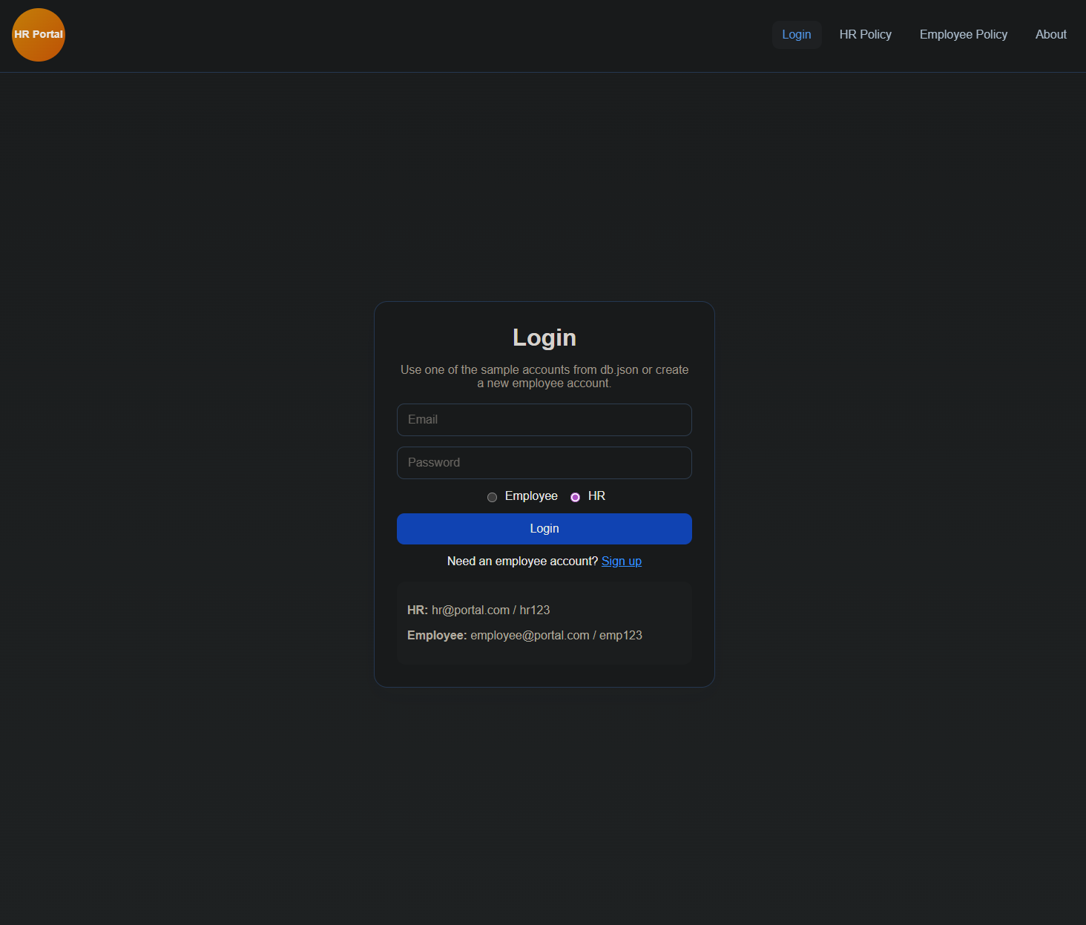

HR POLICY PAGE
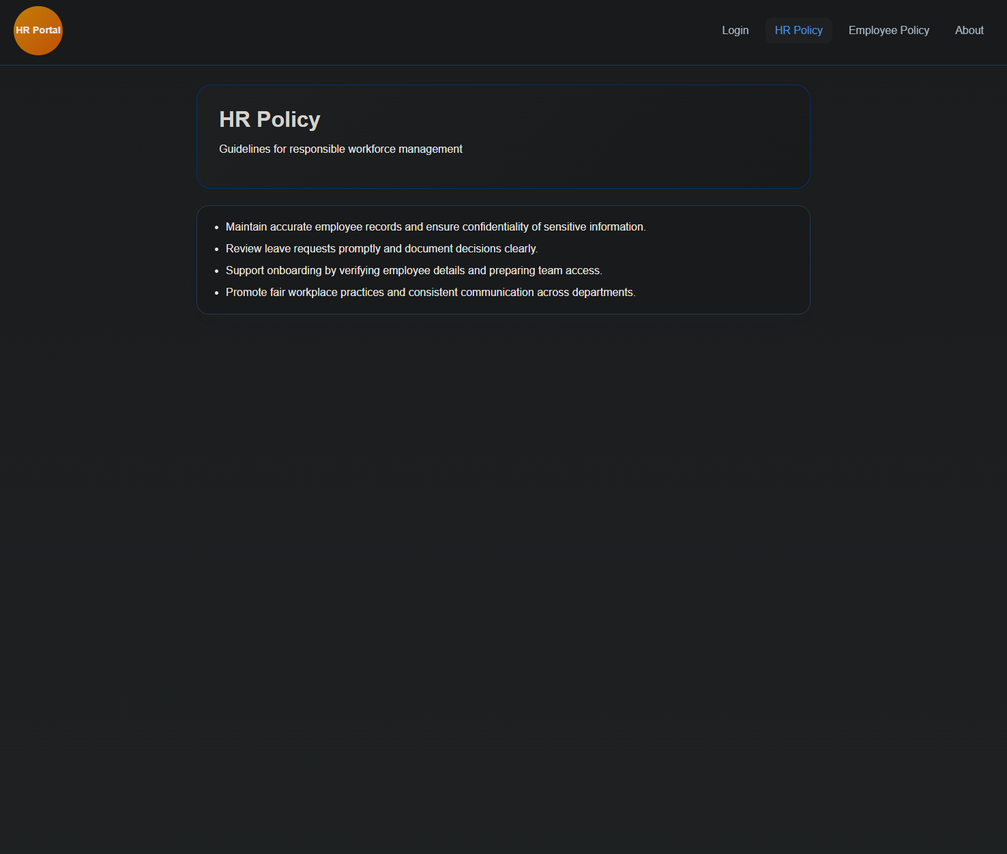

EMPLOYEE POLICY PAGE
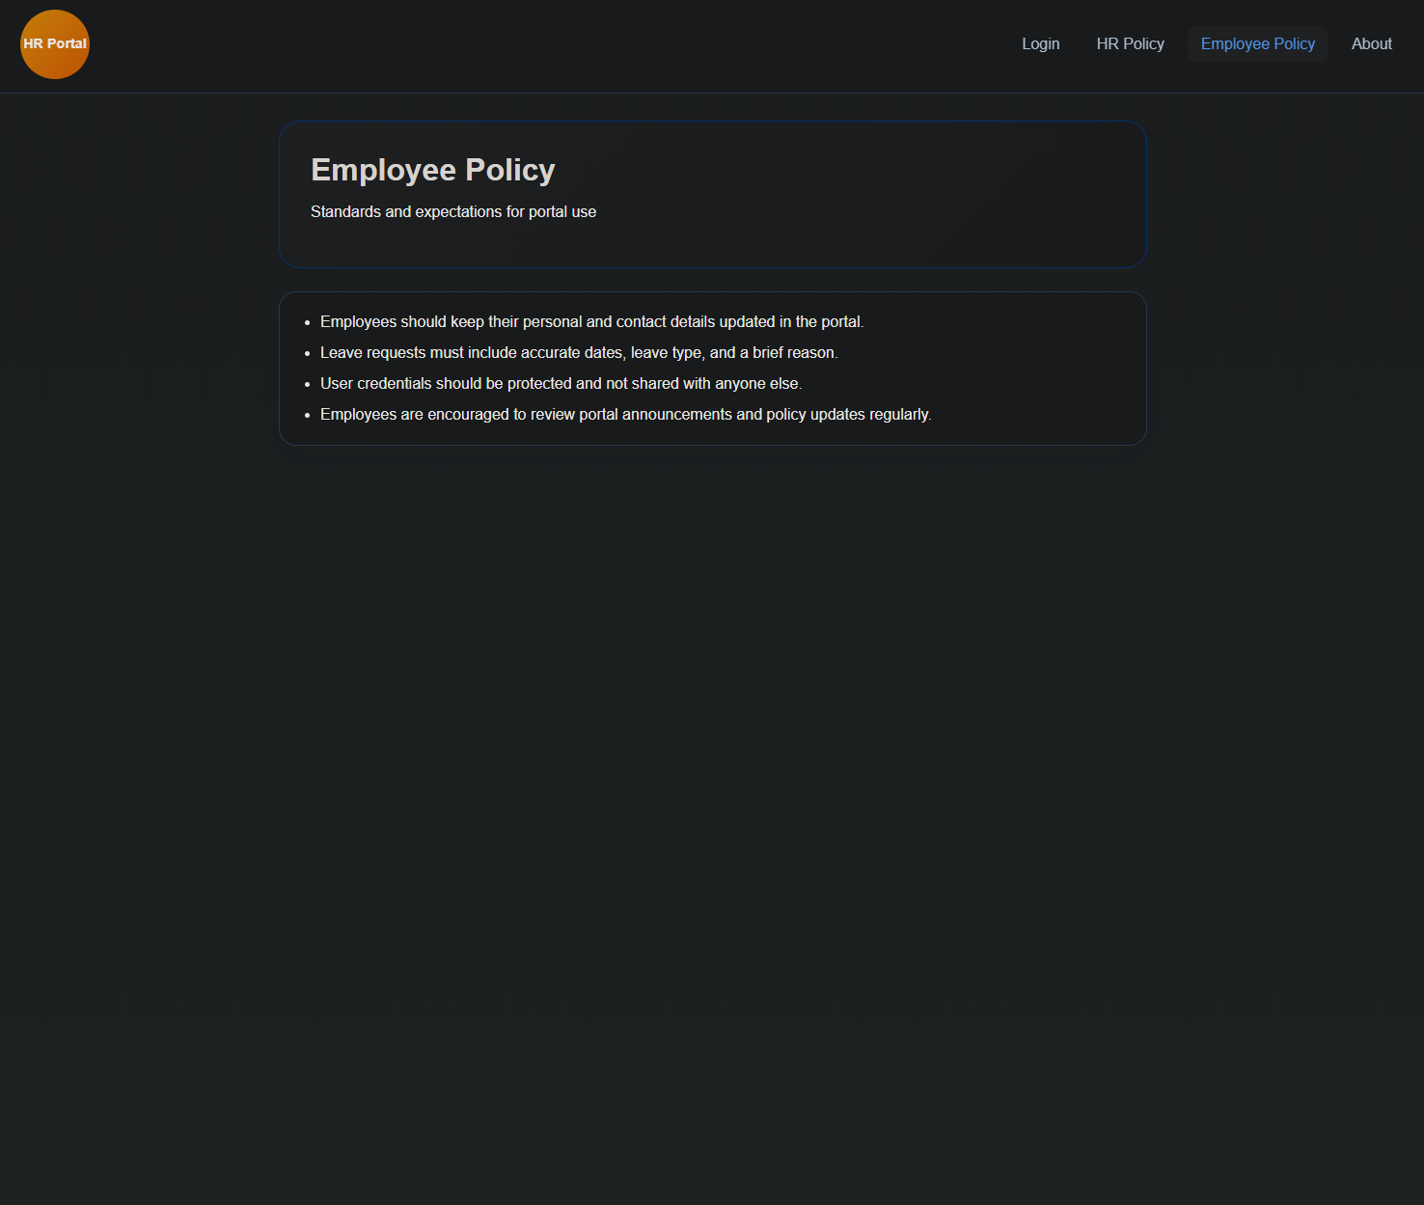

ABOUT PAGE
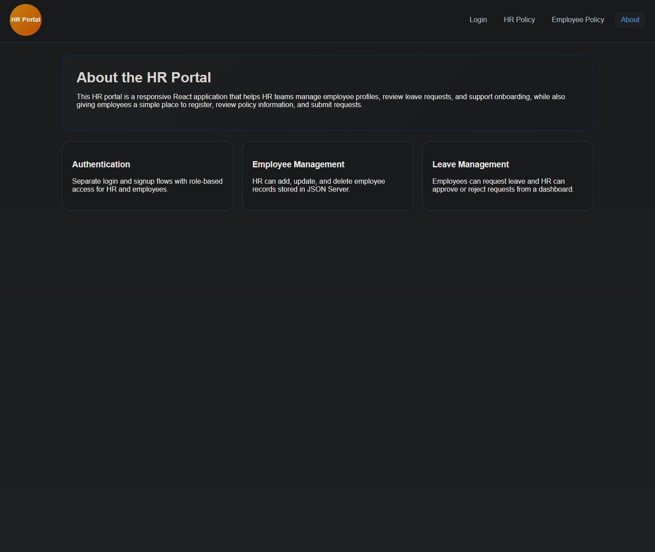

HR DASHBOARD
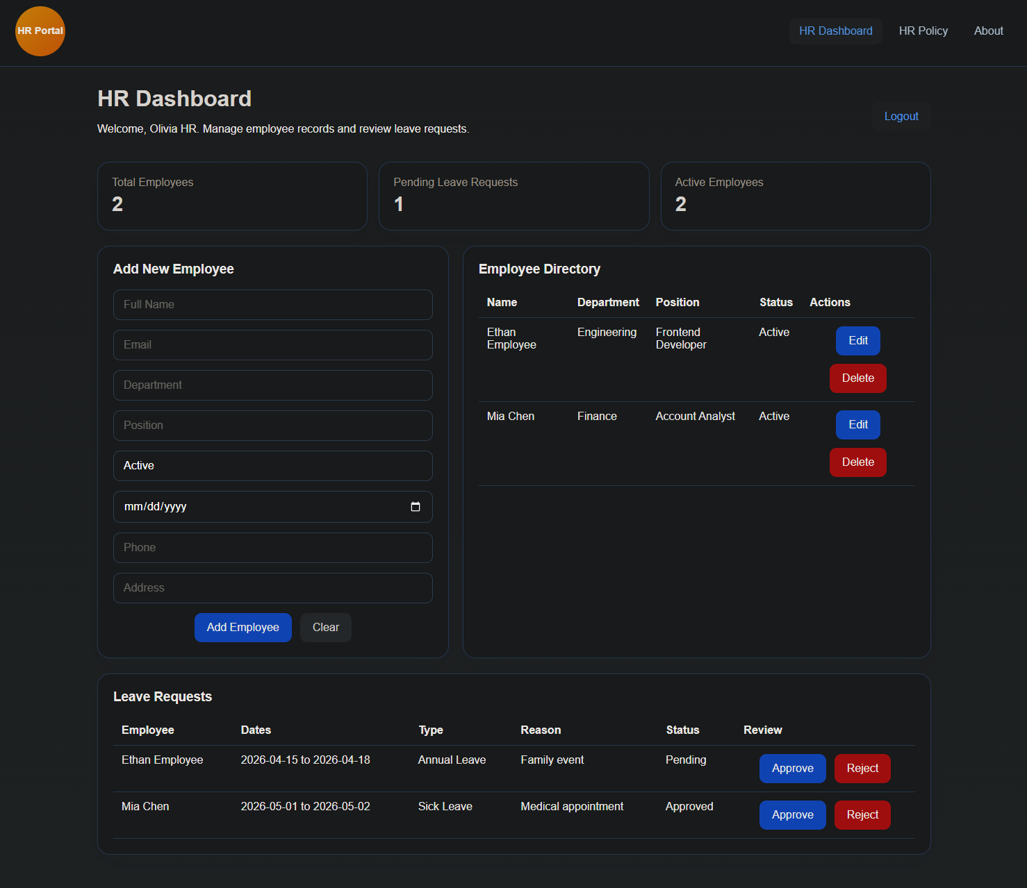

EMPLOYEE DASHBOARD
